**Guided Capstone Project Report**

Big Mountain Resort is a ski resort located in Montana. Recently, the resort installed an additional chair lift which will increase the resort’s operational costs by $1.5 million. To cover the cost of this new feature, the business wants guidance on how to select a better value for their ticket price and suggestions on how to capitalize on its facilities. This project report outlines the data analysis done and summarizes the recommendations for Big Mountain Resort to achieve their goal.

The data set used in this project contained information on over 300 ski resorts in the United States. The information included features at the resorts such as number of different types of ski lifts, vertical drop, number of runs, etc. The target feature of the data set was the Adult Weekend ticket price. A ‘random forest’ model was built to predict this feature.

The business executives of Big Mountain Resort proposed scenarios to either cut costs or increase revenue. Four scenarios were investigated: 1) Closing 10 of the least used runs. 2) Adding a run, increasing vertical drop to 150 feet, and installing a new chairlift. 3) Same as scenario 2, but adding 2 acres of snow making. 4) Increasing the longest run by 0.2 miles and adding 4 acres of snow making.

The model was used to investigate the above scenarios. During the modeling it was assumed that 350,000 people visit the resort over the season and each visitor skis for 5 days. The figure below shows the results from modeling Scenario 1. It can be seen that closing one run does not affect ticket price. If the resort decides to close 3 runs and decrease ticket prices by $0.75 (-$1.25 million revenue) they might as well close 4 and 5, as there is no further loss in ticket price. Closing 10 of the least used runs would lead to a total revenue loss of over $3 million for the year.

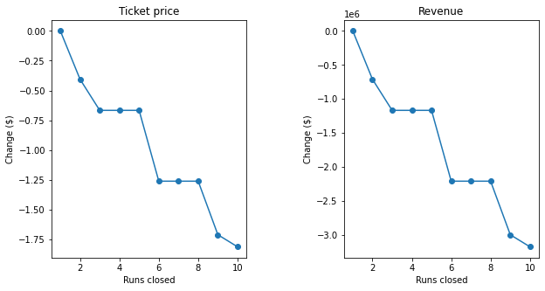

If the resort chose to add a run, increase vertical drop by 150 feet, and install an additional chair lift (Scenario 2), they could increase ticket prices by $1.99 and expect a $3,474,638 increase revenue. For Scenario 3, adding 2 acres of snow to scenario 2 does not make a difference in ticket prices. And modeling Scenario 4 also does not warrant an increase in ticket price.

From our model, I concluded that the best option for Big Mountain Resort is to proceed with Scenario 2 (add a run, increase vertical drop by 150 feet, and install a new chairlift). After increasing their ticket price by $1.99 they could expect to generate approximately $3.5 million more. The cost to install the chair lift is $1.5 million, and thus Big Mountain Resort would profit $2 million for the year.